Barn Cat Program
How It Works
The Longmont Humane Society is pleased to announce the Barn Cat Placement Program. We are looking for cat lovers who have a barn or other secure outdoor structure who are interested in adopting cats that are not suitable for life inside of a house or are unhappy living inside. Cat temperaments range from feral to friendly.
Barn cats benefit their caretakers! Supporting a barn cat is the safest way to control the rodent population in your barn. There are no poisons for children and pets to get into and no need to set nasty traps. They will help keep rodents away from grain and food storage areas, and you'll enjoy watching the cats as well as have the satisfaction of giving them a much-needed home!
Cats that are placed into our Barn Cat Program fall under two main categories:
- Cats whose litter box habits are not consistent enough to be inside only cats.
- Cats who are very fearful and unaccustomed to people.

What Will You Provide?
- A warm, secure, dry barn or building in which the cats can live out their lives.
- The commitment and ability to keep the cats confined to a crate or other fully enclosed structure for three-five weeks to acclimate them to their new environment before release, if they will have access to outside.
- A clean litter box that is scooped and/or cleaned daily while confined.
- A constant supply of dry food and fresh water. While confined and for a short while after release, you will provide a small amount of canned food daily. We want to show them that they have a reason to stay with you and canned food provides that good reason!
- The willingness to trap and vaccinate the cats once every three years, and to provide licensed veterinary care in the event of a severe injury or illness.
- Spending time often making verbal contact to help them acclimate

What will LHS provide?
- All cats will appear to be in good health and have had an exam by our veterinary team
- All cats will be FeLV/FIV negative
- All cats will be spayed or neutered prior to placement
- All cats will be vaccinated against rabies and FVRCP
- All cats will be microchipped and registered to you as their adopter

How about two cats?
Yes! We will be glad to recommend the adoption of two cats as, together, they are most likely to be successful in acclimating to their new environment. The move will be less traumatic and adjustment to their new home easier if they have the security of one or more trusted companions.

Why do they have to be confined for the first 3 weeks?
- Cats need to be confined initially in their new home in order to familiarize themselves with their new environment, so that they will remain on the premises. If this important step is missed, most cats will take off, never to be seen again.
- The cat doesn’t know this is his new home. Be patient and give them the full 3-5 weeks of confinement so that they can get accustomed to the sights, sounds & smells of “home”.
- Some people see confinement as cruel, but a short confinement period is a very necessary part for the cat to survive, and stay around, after the confinement period is over.
In winter, provide thick towels or straw for bedding. Additionally, the caregiver may wish to place bales of straw around the enclosure to help maintain warmth for the confined cats. During spells of freezing weather, the caretaker must be sure to give fresh water throughout the day as the cat’s water may freeze. In summer, proper ventilation is vital to prevent overheating. Cats can and do become overheated.
DO NOT RELEASE IF IT IS RAINING or the POTENTIAL FOR RAIN - Cats find their home by scent and rain will wash it away. Waiting one more day will not hurt. Leave the cages up for an additional five days, so the cats can get back in if they want. After the release, we hope they think of that barn as home and decide to stay.
Cats are territorial creatures. They will usually maintain a home base once their scent has been established, a continuous food source is provided, and they feel safe.

In order to adopt a barn cat, we ask that you:
* Consider adopting two cats as companions.
- Provide an enclosed barn or other heated outdoor structure.
- Plan on placing the cat in a large dog crate, inside an enclosed room, for 3 weeks. Food, water, litter box, and bedding in this crate.
- After the 3 week period in the crate, open the crate door at night, and allow them to explore the enclosed room.
- After 1 week inside the enclosed room, allow them to have access to the entire barn AND continue to have access to their initial crate. No rain/snow on this day. Barn should be closed and secured so the cat cannot get out of the barn.
- After 1 week having access to the entire barn, ok to allow the cat outside of the barn to explore outside, if you desire. Be sure that the cat can always get back inside the barn at anytime.
- Feed wet food EVERY DAY, even twice a day for breakfast and dinner. This will help them return home!
- Food and water and a litter box should be maintained daily.
- Bring the cat(s) to the vet in three years for an update on their vaccinations.

Interested in a Barn Cat? Plan to do the following in a heated outdoor structure

Cat in large dog crate with food, water, litterbox, bedding
THREE WEEKS
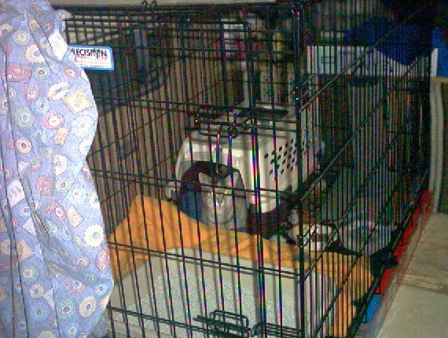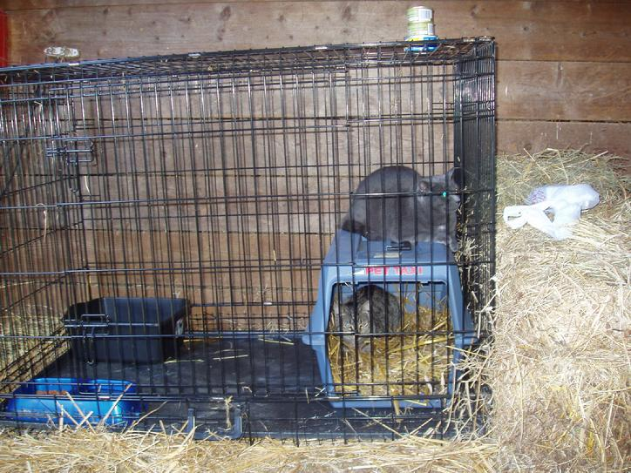

Open door to crate while crate/cat remain in enclosed room, such as a tack room
ONE WEEK
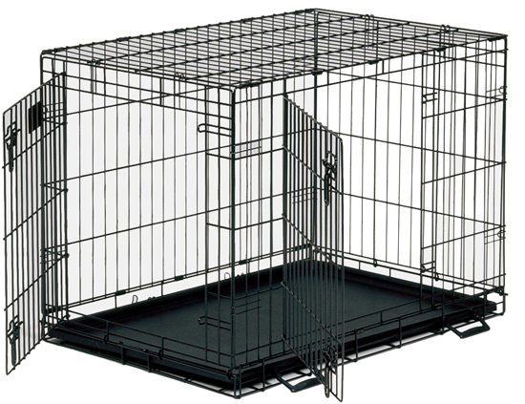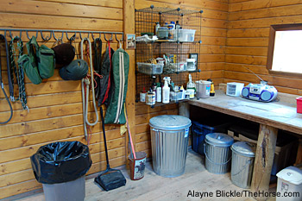

Open door to enclosed room while crate/cat remain
inside barn with no outside access
ONE WEEK
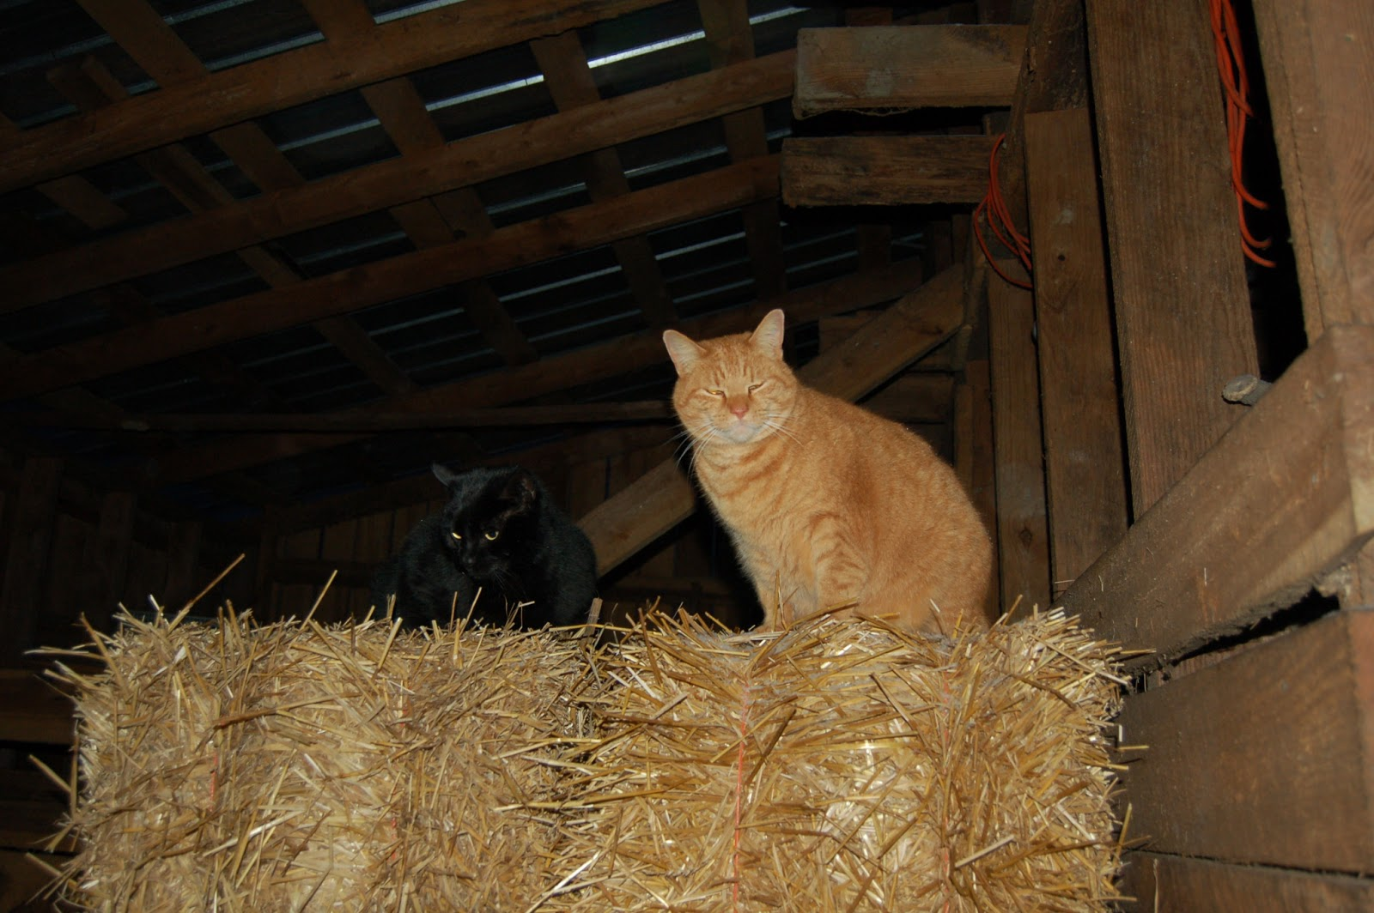

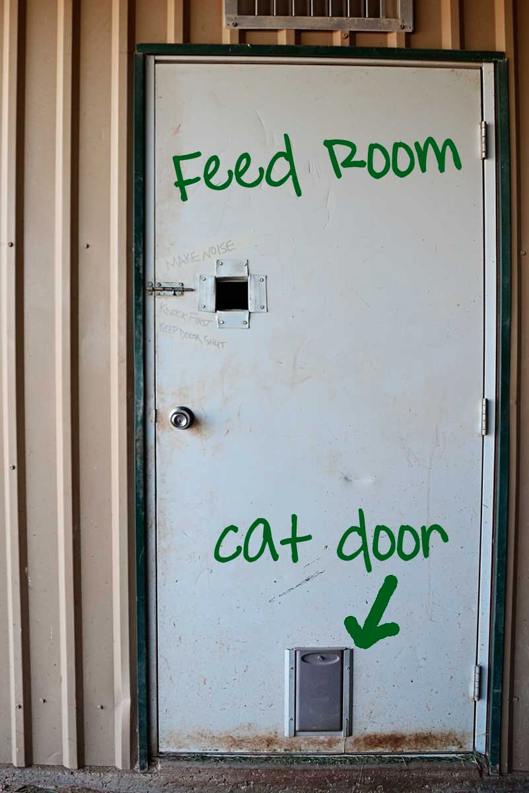
Allow access to outside with ability to return to barn FEED CANNED FOOD EVERY DAY

